To illustrate how the commands work, I will first create a dataset with a small trend:
Type the following commands:
set.seed(3012008)
x=rnorm(100)
y=-x+I(x^2) +rnorm(100)

(Here, the set.seed allows the numbers sampled from the random normal to be reproduced; once we plot the data, we should see identical results.)
To visualize the data, type: plot(y~x)
Your graph should look like this:
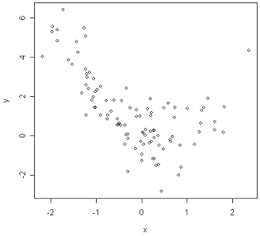

Task 1a: Draw a Line Above the Regression Line
This command will draw a line with 12 points above it. In the argument of the function, n-denotes the number of points below the line, and type=”l” means that you will draw a line in the graph (in red).
Type the following command:
locator(n = 12, type = "l", col="red")
and click on the two points you want the line to go through. To stop the function, right click on the graphics screen and select “stop” from the menu. Now R will then tell you the coordinates of the two points that the line went through.
To find the equation of the line, you can rerun the command again, only this time, saving the output in another variable (call it a):
a<-locator(n = 12, type = "l", col="red")
Now the equation for the line is (y=mx+b):
m=( a$y[2]- a$y[1])/( a$x[2]- a$x[1]); m # slope
b=a$y[1]-m*a$x[1]; b # intercept
To plot this line in your graph, use:
abline(a=b, b=m, col=”blue”)
where the function adds a line with the intercept argument a and the slope argument b.

Task 1b: Identify the Indices of the Observation Above the Line
Type the following command:
identify(y~x)
and by clicking on the points above the line (you select which to click on) R will tell you their indices in the graphics window. To stop the function, right click on the graphics screen and select “stop” from the menu.
The result for this dataset is shown below.
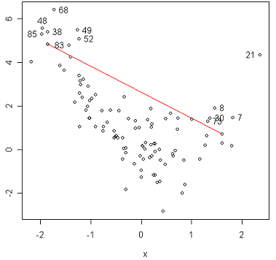

Task 2: Want to See Where the Top 10% of the Wines Are in the Plot
First we will determine how many wines from your list make up the top 10% of our dataset. We need to sort our data (to have the values in decreasing order and save the output as a new variable that we will work with):
a=sort(y, decreasing=T)
Now to calculate how many observations are the top 10% of the data, we use:
b=round((length(y))*.1, digits=0); b
In the formula above, digits=0 rounds our result to whole numbers. The result from this command now tells you that 10% corresponds to 10 numbers in our dataset. (We knew that already since we had 100 observations to start with. But this is done to automate the procedure.) Now a[b] corresponds to the last value in the top 10% of our data.
Now to select in the plot which points are more important, we can start with a fresh plot first via: plot(y~x) and type:
points(y[which(y>=a[b])]~x[which(y>=a[b])], col="red")
which will highlight the top b values (in this case 10) in the plot, in red.
This command extracts those values in y (via which(.), as which(.) returns the index of some condition; in this case, we want all the indices for the values corresponding to the top 10% of our data) that correspond to the top b values in y by y[.]. Then it finds the corresponding x coordinates, and plots the selected y against the x values via points(.).
The result is shown below.
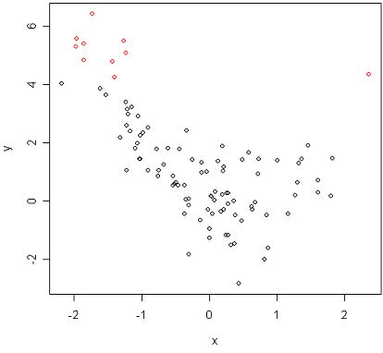

Appendix: R Code
set.seed(3012008)
x=rnorm(100)
y=-x+I(x^2) +rnorm(100)
plot(y~x)

locator(n = 12, type = "l", col="red")
a<-locator(n = 12, type = "l", col="red")
m=( a$y[2]- a$y[1])/( a$x[2]- a$x[1]); m # slope
b=a$y[1]-m*a$x[1]; b # intercept
abline(a=b, b=m, col=”blue”)

identify(y~x)

a=sort(y, decreasing=T)
b=round((length(y))*.1, digits=0); b
plot(y~x)
points(y[which(y>=a[b])]~x[which(y>=a[b])], col="red")

